# Homework

## Software Development Models

### Guess which methodology corresponds to the diagram

Below you have 6 diagrams that represent 6 different development models, have a good look and fill your suggestions in the table below.

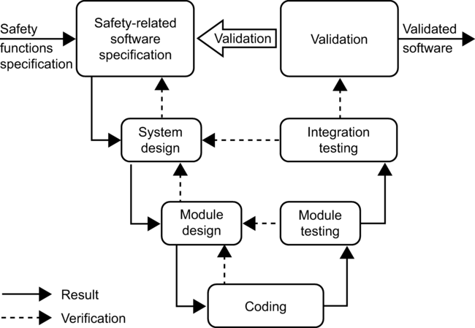

Figure 1

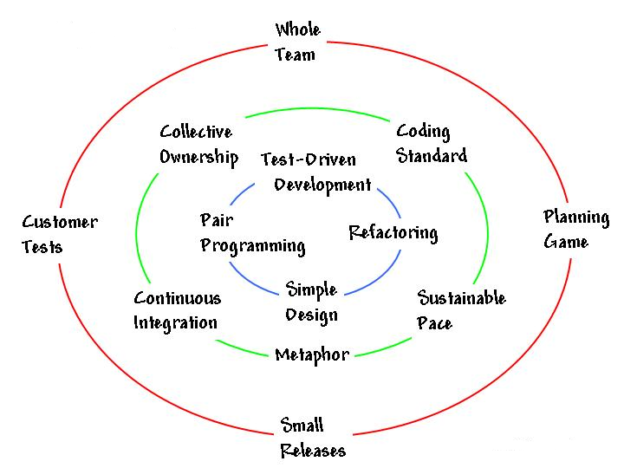

Figure 2

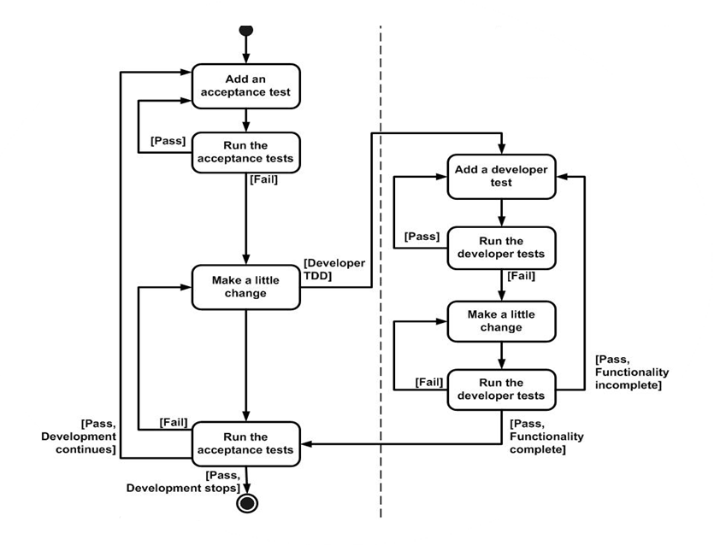

Figure 3

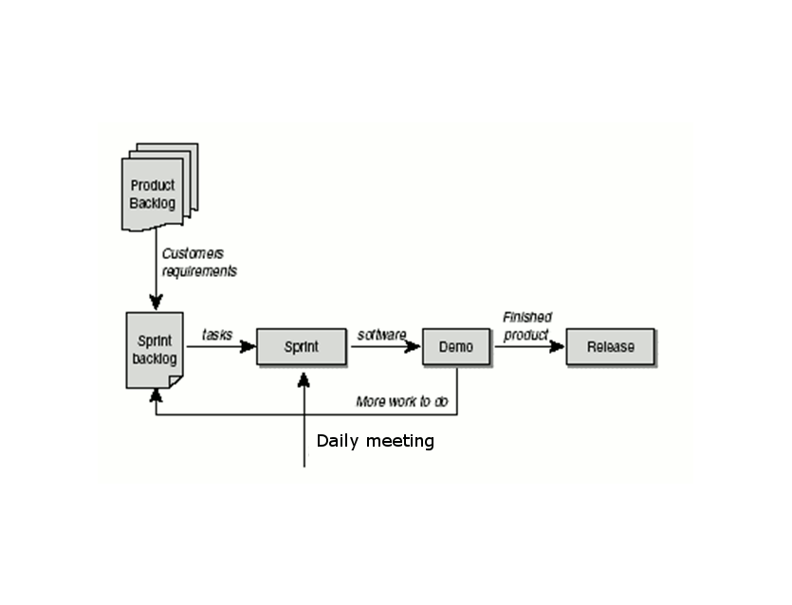

Figure 4

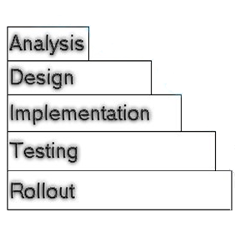

Figure 5

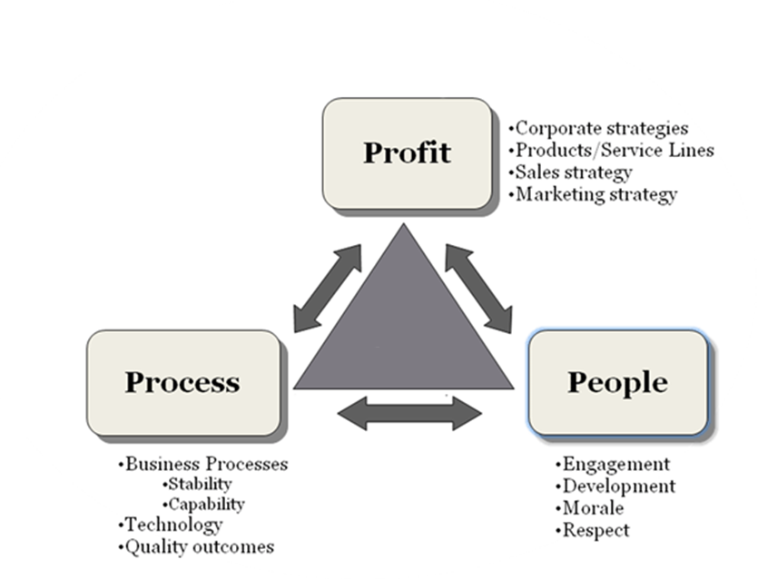

Figure 6

|  |  |
| --- | --- |
| Figure # | Methodology name |
| 1 | V-model (Sequential Development Model) |
| 2 | Extreme Programming (XP) |
| 3 | Test-Driven Development (TDD) |
| 4 | Scrum |
| 5 | Waterfall |
| 6 | Lean |

*(6 positions X 1 point)* ***6 points***

### Compare the methodologies

Below is a table, where 3 different methodologies are compared. In the first row as a heading you see the names of the methodologies and in the first column there are the aspects of assessment. Your task is to give evaluation of the criteria from the first column by choosing the best suit from the boxes to the right of the table.

Required/Planning and closure only

Determined during planning/ Set during project

Determined during planning/ Set during project

Determined during planning/ Set during project

Limited – cookbook approach/ Unlimited during iterations

Planning only/ Throughout/At end of each iteration

Low/ Medium/ High

Training prior to project/ Teamwork during project

|  |  |  |  |
| --- | --- | --- | --- |
|  | Waterfall | Iterative | Scrum |
| Defined process | Required | Required | Planning and closure only |
| Final product | Determined during planning | Set during project | Set during project |
| Project cost | Determined during planning | Set during project | Set during project |
| Completion date | Determined during planning | Set during project | Set during project |
| Responsiveness to environment | Planning only | At end of each iteration | Throughout |
| Team flexibility, creativity | Limited – cookbook approach | Limited – cookbook approach | Unlimited during iterations |
| Knowledge transfer | Training prior to project | Training prior to project | Teamwork during project |
| Probability of success | Low | Medium | High |

*(24 positions X 1 point)* ***24 points***

### Which of the following artifacts/ events/ principles/activities belong to the listed methodologies?

|  |  |  |  |
| --- | --- | --- | --- |
| TDD | XP | Lean | Scrum |
| Refactor | Metaphor | Eliminate waste | Daily Stand up meeting |
| Design before you write your functional code | Courage | Identify Value | Product Owner |
| Keep it simple | Pair programming |  | Burndown chart |
|  |  |  |  |

Product owner

Eliminate waste

Courage

Design before you write your functional code

Burndown chart

Metaphor

Identify Value

Refactor

Daily Stand up meeting

Keep it simple

Pair programming

*(11 positions X 1 point)* ***11 points***